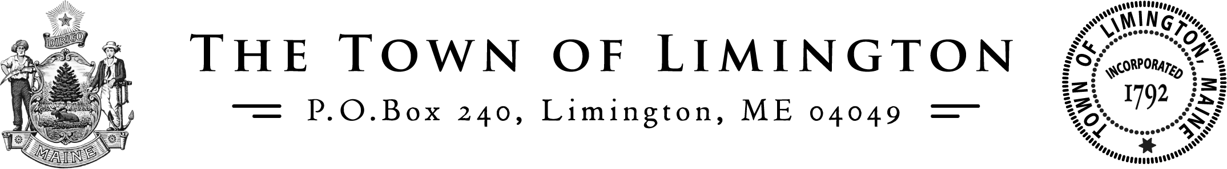
Request for Bids for Roadway Paving 2024
The Town of Limington, Maine is requesting bids for roadway paving for 2024.
SEALED bids are to be delivered to The Assistant to The Selectboard, at the Limington Municipal Complex at the address below, NO LATER THAN 4:30 pm, June 12, 2024. All bids MUST use the designated bid form and should be marked ROADWAY PAVING BID.
Nikki Kinne
Assistant to The Selectboard
425 Sokokis Avenue
PO Box 240
Limington, Maine 04064
(207) 637-5210
Bids must be sent through U.S. Mail, Express Mail or hand-delivered. Bids are not accepted through e-mail or fax. Proposals received after the scheduled due date and time will not be accepted.
A copy of the RFP can be secured from the Selectboard Assistant, or on the Town’s website: www.limington.net
The Town reserves the right to accept any proposal and reject any and all proposals, should it be deemed in the best interest of the Town to do so.
Bids will be opened publicly at the Selectboard’s Meeting on Thursday, June 13, 2024 at 7:00 pm
Additional information or clarification can be secured by contacting:
Shawn Jordan-Limington Road Commissioner
207-423-2174 (CELL)
207-637-5199 (Office)
publicworks@limingtonmaine.gov

